Lesson 16: Graphs of Sine & Cosine
Math 2412 Precalculus · Unit 3: Trigonometric Functions & Triangles · Student Guided Notes
Name: ______________________________ Date: ______________

Lesson objective
Students will graph sine and cosine, find the amplitude, period, phase shift, and vertical shift of $y=Asin(Bx−C)+D$ and $y=Acos(Bx−C)+D$, sketch these graphs from five key points, and write an equation from a graph.

Before class
Complete these short tasks before the lesson. They review skills this lesson builds on.
- Give $sin x$ and $cos x$ for $x=0$, $π/2$, $π$, $3π/2$, and $2π$ (Lesson 15).
- Describe how $y=−2f(x−3)+1$ is transformed from $y=f(x)$ (Lesson 5).
- Solve $2x−π/3=0$ and $2x−π/3=2π$ for x.

Skill 16.1: The Sine and Cosine Graphs

Key ideas
As t goes around the unit circle, $sin t$ is the height of the point and $cos t$ is its horizontal position. Plotting those values against t gives two waves.
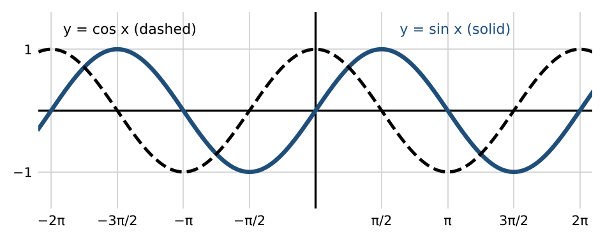
 | y = sin x | y = cos x
Period | ________ (1) | $2π$
Domain | ________ (2) | (−∞, ∞)
Range | ________ (3) | [−1, 1]
Even or odd | ________ (4): symmetric about the origin | ________ (5): symmetric about the y-axis
Key points on [0, 2π] | (0, 0), (π/2, 1), (π, 0), (3π/2, −1), (2π, 0) | (0, 1), (π/2, 0), (π, −1), (3π/2, 0), (2π, 1)

Skill 16.2: Amplitude and Period

Key ideas
For $y=Asin(Bx−C)+D$ and $y=Acos(Bx−C)+D$: amplitude = ______________ (6) period = ______________ (7)
- The amplitude is half the distance from the maximum to the minimum: $(\frac{1}{2})(max−min)$.
- If $A<0$, the graph is ______________ (8) across its midline.
- A larger B squeezes the wave: more cycles fit in the same space, so the period is shorter.

Example
- $f(x)=sin(π\frac{x}{6})$: $B=π/6$, period $2π/(π/6)=12$.
- $f(x)=cos(\frac{x}{3})$: $B=\frac{1}{3}$, period $2π/(\frac{1}{3})=6π$.
- $f(x)=−4sin x$: amplitude $\left|−4\right|=4$, reflected across the x-axis.
- $f(x)=(\frac{1}{2})sin x$: amplitude $\frac{1}{2}$.

Practice
a. Find the amplitude and period of $y=5cos(4x)$. | b. Find the amplitude and period of $y=−(\frac{2}{3})sin(πx)$. | c. A sine graph has maximum 7 and minimum −3. Find its amplitude.

Skill 16.3: Phase Shift and Vertical Shift

Key ideas
Phase shift = ______________ (9) (right if positive, left if negative). Vertical shift = D; the midline is ______________ (10).
- Factor B out to see the shift: $sin(Bx−C)=sin(B(x−\frac{C}{B}))$.
- With a vertical shift, the range is [D − |A|, D + |A|].

Example: identify the features
Function | Amplitude | Period | Phase shift | Range
$f(x)=sin(x+π/6)−2$ | 1 | $2π$ | ________ (11) (left) | ________ (12)
$f(x)=3cos(x−π/2)$ | 3 | $2π$ | ________ (13) (right) | ________ (14)

Practice
a. Find the phase shift and midline of $y=2sin(3x−π)+4$. | b. Find the phase shift of $y=cos(2x+π/2)$.

Skill 16.4: Sketching from Key Points

Steps: sketch $y=Asin(Bx−C)+D$ or $y=Acos(Bx−C)+D$
- Find the amplitude $\left|A\right|$, the period $2π/B$, the phase shift $\frac{C}{B}$, and the midline $y=D$.
- The cycle starts at the phase shift and ends one period later. Divide it into ______________ (15) equal parts to get five x-values.
- Use the pattern for the basic graph: sine goes midline, max, midline, min, midline; cosine goes max, midline, min, midline, max. If $A<0$, swap max and min.
- Plot the five key points, draw a smooth wave, and extend it in both directions.

Example 1: $y=(\frac{1}{2})cos(\frac{x}{3}−π/3)$
- Amplitude $\frac{1}{2}$; period $2π/(\frac{1}{3})=6π$; phase shift $\frac{π/3}{\frac{1}{3}}=π$; midline $y=0$.
- Step $6π/4=3π/2$. Key x-values: $π$, $5π/2$, $4π$, $11π/2$, $7π$.
- Cosine pattern: (π, 1/2), (5π/2, 0), (4π, −1/2), (11π/2, 0), (7π, 1/2).
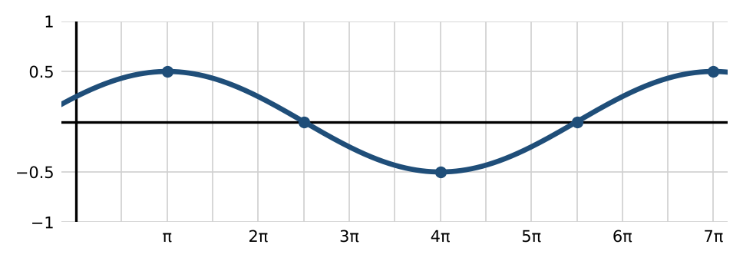

Example 2: $y=−2sin(π\frac{x}{2})$
- Amplitude 2, reflected; period $2π/(π/2)=4$; no phase shift; midline $y=0$.
- Key x-values 0, 1, 2, 3, 4. Reflected sine pattern: (0, 0), (1, −2), (2, 0), (3, 2), (4, 0).
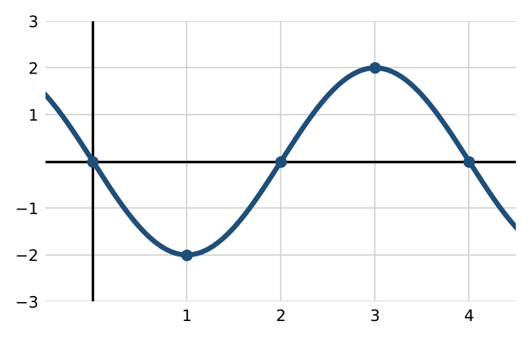

Practice
a. Sketch one period of $f(x)=3sin(π\frac{x}{4}−π/4)$. Label the five key points.
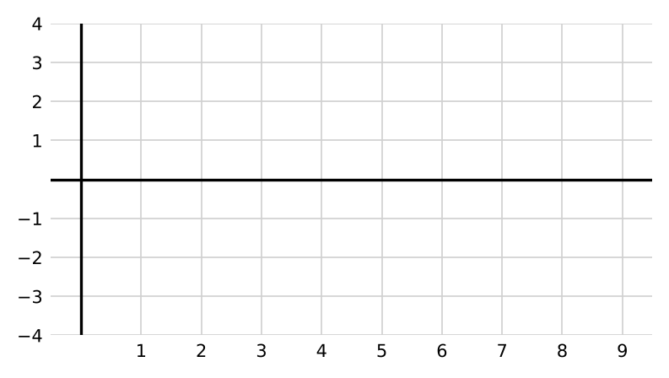
b. Sketch one period of $f(x)=−2cos(π\frac{x}{2}+π)+3$. Label the five key points.
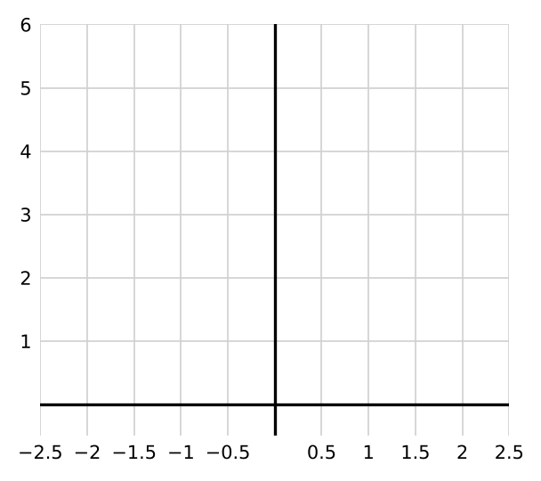

Skill 16.5: Writing an Equation from a Graph

Steps
- Find D (the midline) as the average of the maximum and minimum, and the amplitude as half their difference.
- Find the period from one full cycle, then $B=2π/period$.
- Choose cosine if a maximum is on the y-axis (or sine if the graph crosses the midline going up there); otherwise use a phase shift.

Example
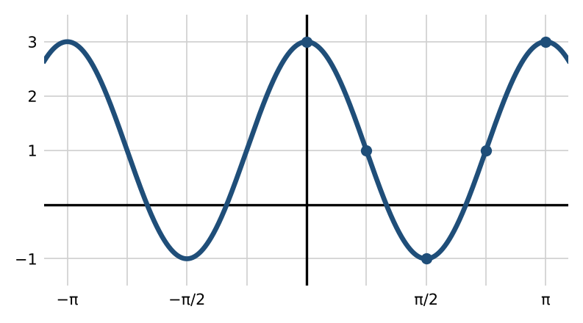
Max 3, min −1: $D=1$ and $A=2$. One cycle from 0 to π: period π, so $B=2π/π=2$. A maximum is on the y-axis, so use cosine: $y=2cos(2x)+1$.

Practice
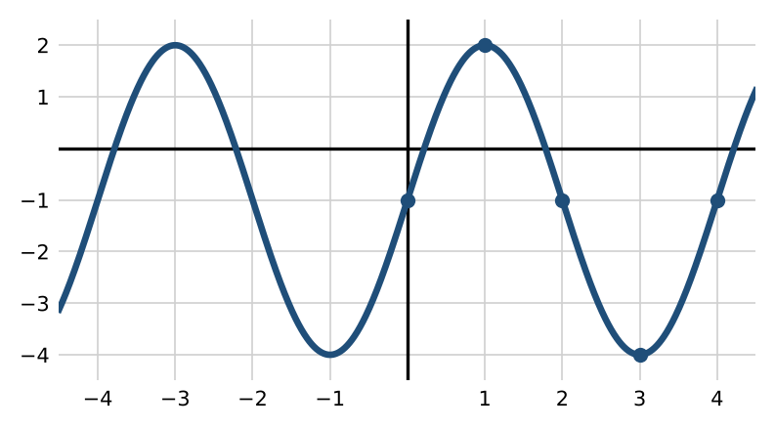
a. Write an equation for the graph above.

Exit check
1. Find the amplitude, period, and phase shift of $y=4cos(2x−π/2)$.

2. Find the range of $y=−3sin x+5$.

3. List the five key x-values for one period of $y=sin(x−π/3)$.

